**Problem Statement:**

Implement view in hive by following the steps in the below blog

<https://acadgild.com/blog/hive-view-introduction/>

Solution:

Dataset:

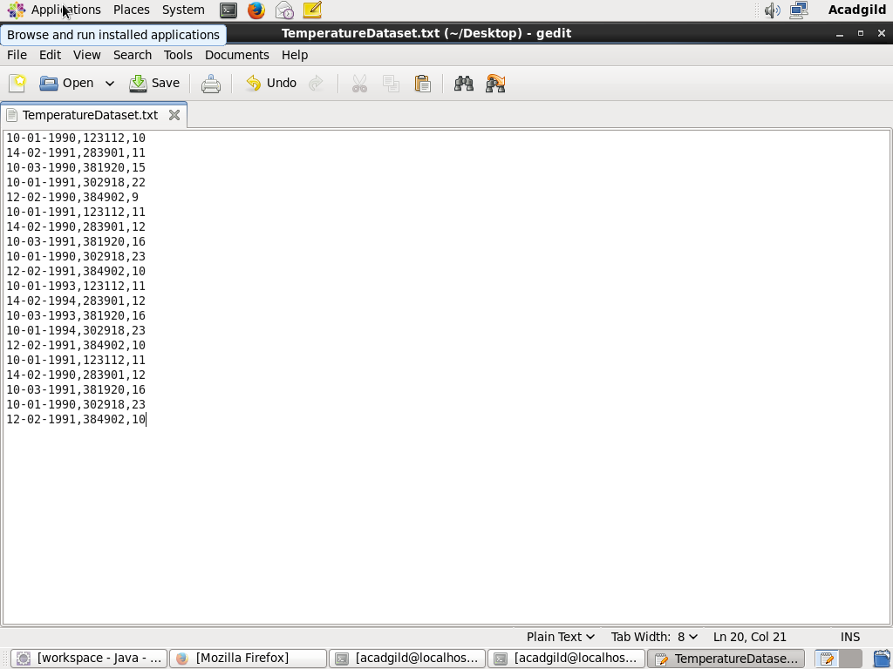

***Creating the view named as temperature_data and displaying the values in the view***

